LESSON PLAN

SCHOOL: HOPE HIGH SCHOOL DATE: 20th /01/2020 TEACHER: MR OCHWO TIME: 3.30pm-4.00pm
CLASS: DURATION: 30 min
Number of pupils:
Boys…4
Girls…4
SUBJECT: ICT
Theme:
TOPIC: INTRODUCTION TO ICT

Learning outcomes: Learners should be able to describe a set and identify elements of a set (K, U, S, V)

In this lesson, the following will be acquired as learners learn how to describe a set.
- Values (creativity and innovation, hard work for self-reliance, honesty, uphold and defend the truth at all times
- Generic skills (CTPS, communication, cooperation and self -directed learning)
- KLO (self-assured individuals, lifelong learner, positive contributors in society)
- Cross cutting issues (mixed ability and involvement, health awareness)

RATIONALE
In this lesson learners will use the knowledge of sorting and grouping items that are the same to understand the meaning of sets. Through guided discovery, individual work and group work learners will sort items that are the same and pile them together. They will then pack them in the improvised shelves to bring out the meaning of sets. By learning sets, learners will appreciate the value of sorting and grouping items with the same characteristics and how this brings about identification of different items and neatness. The knowledge of sets is used in many areas of life such as piling of items of the same characteristics in the market and priced differently, library arrangements, supermarket stalls, drug shops, chemical arrangements in the laboratories etc. This is the first lesson out of a series of 15 lessons in set theory.

Pre- Requisite Knowledge
Pupils already have knowledge on sorting, grouping homogenous items together, from S.1.

Teaching learning materials:
Cups, plates, markers and empty boxes, Rwenzori water bottles.

Reference:
Lower Secondary Curriculum, Mathematics Syllabus NCDC 2019 Pg 41
Learners Text book
Teachers’ guide book

Time/ Stage | Teacher Activity | Learners’ Activity | Indicators to learning/ assessment
10 minutes  Introduction stage | Scenario  Mr. Baale went to do shopping for his family and bought the following items. plates, cups, mineral water. and markers He handed over to his family members who were to keep the items.  Task  What would you do to neatly keep the items?  (Teacher moves around the class to see how learners are working with a purpose of checking on those with misconceptions) | Leaners are doing in groups  Expected answer  Alternative 1  - We would first remove the items from the bags  - Then sort them out according to their likeness  - Pack the same item in one shelf  Alternative 2  - Others will just pick the items direct from the bags straight to the shelves but being mindful that they have sorted them to their respective groups  Alternative 3  - Others may just simply pack the items without sorting them according to their likeness.  (Probe to find out why they chose to pack items the way they have done. Learners will explain why. The teacher uses other learners to explain why items must be sorted according to their likeness ) | Check learner’s ability to;  - Observe and describe objects  - Sort homogenous objects  - Creatively group objects in different boxes  - Share ideas in group through discussion  - Collaborate and take roles in the groups
15 Minutes  Lesson development stage | KEY QUESTION  How can we identify and describe a set?  (Teacher allows the learners to think in groups and discover this on their own).  ( Think : Group share strategy)  A teacher uses the items bought by Mr. Baale.  Task  - Describe the items packed in the shelves  - Why have you packed the items in that order?  How would you describe the following collection of items  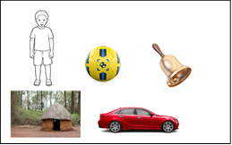  ( Teacher emphasizes what to consider when describing a set) | Anticipated responses  - By looking at the items that form that set  - By looking at what common characteristic relates the items  Anticipated responses  Alternative response 1  - Some learners will say ;  A set of cups  A set of mineral water bottles  A set of Plates  A set of markers  Alternative response 2  While others may say;  - Others are likely to draw the items and name the set  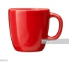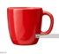 A set of cups/ A group of cups  A set of mineral water bottles  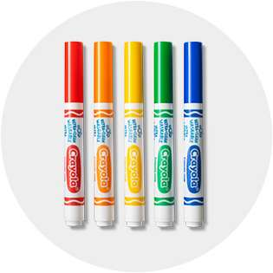set of markers  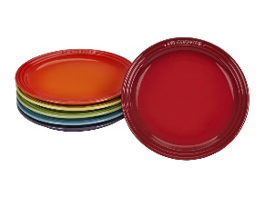A set of plates  Alternative response 2  Some learners will realise that one shelf does not have any items placed in it. And therefore teacher will probe to find out if the empty box describes a  Anticipated responses  - Because they resemble  - Because they are the same  Anticipated responses  Set cannot be distinctively described because the items in it are mixed. | Check learner’s ability to;  - Identify the grouped items in the boxes as different sets (by sorting and grouping)  - Describe a set as a well-defined collection of distinct objects (by labeling the different boxes)  - Handle the objects with care while grouping them  - Confidently communicate as they share their ideas to the rest of the class  .  Learners will share their ideas before the class to bring out the identification and description of a set.  Check learner’s ability to;  - Describe the elements of a set  - Learners ability to name and label the sets correctly  - Describe the empty shelf to represent an empty set
10 Minutes  Evaluation  (Exercise to check on attainment of learning) | Describe the following sets  bBall, Basket, boy,bottle,bread | Learning points  - A set of books  - A set of coloured flowers  - A set of leaves  - A set of words with 1st letter as B | Check whether learners are able to use the knowledge, understanding and skills to respond to the exercise
5 Minutes  Conclusion stage | Recap: How can we describe elements of a set?  Of what economic value is learning sets? | Learners should be able to respond by saying;  - A set is a collection of well-defined members or elements  I will use the knowledge of describing sets to pack items in a shop of same size with same price market, foods in a restaurant are arranged and labelled ,packing items in boxes etc. | Check whether learners were able to  describe a set and identify elements of a set

WORK SHEET FOR LEARNERS
In your groups, discuss and fill in the table
ITEMS | DESCRIPTION OF ITEMS | ITEM | DESCRIPTION OF ITEMS
 |  | 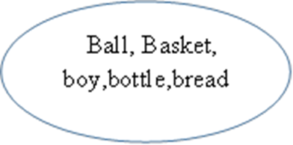
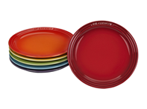 |  | 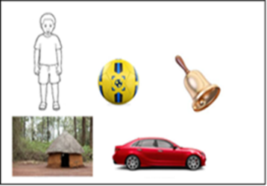
- Of what economic importance is this competency of describing sets?

WORK SHEETS
Mr. Baale went to do shopping for his family and bought the following items. plates, cups, mineral water and markers He handed over to his family members who were to keep the items.
Task
What would you do to neatly keep the items?

